**Industrial Internship Report on**

**”Prediction of Agriculture Crop Production in India”**

**Prepared by**

**[Potla Keerthana]**

|  |
| --- |
| *Executive Summary* |
| This report provides details of the Industrial Internship provided by upskill Campus and The IoT Academy in collaboration with Industrial Partner UniConverge Technologies Pvt Ltd (UCT).  This internship was focused on a project/problem statement provided by UCT. We had to finish the project including the report in 6 weeks’ time.  My project was on Prediction of Agriculture Crop Production in india  This internship gave me a very good opportunity to get exposure to Industrial problems and design/implement solution for that. It was an overall great experience to have this internship. |

**TABLE OF CONTENTS**

1 Preface 3

2 Introduction 4

2.1 About UniConverge Technologies Pvt Ltd 4

2.2 About upskill Campus 8

2.3 Objective 9

2.4 Reference 9

2.5 Glossary 10

3 Problem Statement 11

4 Existing and Proposed solution 12

4.1 Code Submission……………………………………………………………………………………………………………………………..13

4.2 Report submission (Github link) ………………………………………………………………………………………………………13

5 Proposed Design/ Model 14

5.1 High Level Diagram (if applicable) 15

5.2 Low Level Diagram (if applicable) 15

5.3 Interfaces (if applicable) 16,17

6 Performance Test 18

6.1 Test Plan/ Test Cases 19

6.2 Test Procedure 19,20

6.3 Performance Outcome 20

7 My learnings 21

8 Future work scope 22

# Preface

The Data science and machine learning internship duration was of 6 weeks. 1st week of the internship was to explore the problem statement which were provided by the management and understand their background in order to start with the project. Also learned about UCT. 2nd week of the internship was to understand and follow the project instructions provided by UCT. And, also to plan for the solution of the existing problem. 3rd week of internship is to start for the actual Internships are an opportunity to network with great people and sharpen your skills before entering the workforce. They also help tremendously with figuring out your true passion. Companies often look at them as a way to gain experience and exposure to make a smooth transition into your role when hired.

Agriculture is the main occupation for the people of India, covering 60% of the nation land and catering the basic needs of 1.2 billion people. For the benefit of the farmers, modernization of agriculture procedures is carried out today. The crop yield or production majorly depends on the weather conditions, environmental changes, rainfall (which at times is uncertain), water management, and the utilization of pesticides. Therefore, farmers are not able accomplish expected yield of crop. Now a days data mining, machine learning as well as deep learning approaches are used by various researchers to enhance and improve the yield of crop and their quality. Machine Learning can gain proficiency with the machine without characterized computer programming, so it improves machine execution by distinguishing and portraying the consistency and pattern of drive information. In this work various machine learning approaches such as Linear Regression, Gradient Boosting Regressor, Random Forest Regressor, Decision Tree Regressor, Polynomial Regression, Ridge Regression have been used for yield prediction on crop yield dataset of different states and considering varied crops.

This internship gave me a very good opportunity to get exposure to Industrial problems and design/implement solution for that. It was an overall great experience to have this internship.working of the project. 4th week of the internship was so to continue with the work on the project and check whether there are improvements required for the project. 5th week of the internship was to validate your implementation and evaluate your performance. And the final week of the project is to submit your project report and get certification.

# Introduction

## About UniConverge Technologies Pvt Ltd

A company established in 2013 and working in Digital Transformation domain and providing Industrial solutions with prime focus on sustainability and RoI.

For developing its products and solutions it is leveraging various**Cutting Edge Technologies e.g. Internet of Things (IoT), Cyber Security, Cloud computing (AWS, Azure), Machine Learning, Communication Technologies (4G/5G/LoRaWAN), Java Full Stack, Python, Front end**etc.



1. UCT IoT Platform **(****)**

**UCT Insight** is an IOT platform designed for quick deployment of IOT applications on the same time providing valuable “insight” for your process/business. It has been built in Java for backend and ReactJS for Front end. It has support for MySQL and various NoSql Databases.

* It enables device connectivity via industry standard IoT protocols - MQTT, CoAP, HTTP, Modbus TCP, OPC UA
* It supports both cloud and on-premises deployments.

It has features to  
• Build Your own dashboard  
• Analytics and Reporting  
• Alert and Notification  
• Integration with third party application(Power BI, SAP, ERP)  
• Rule Engine

 

1. **Smart Factory Platform (****)**

Factory watch is a platform for smart factory needs.

It provides Users/ Factory

* with a scalable solution for their Production and asset monitoring
* OEE and predictive maintenance solution scaling up to digital twin for your assets.
* to unleased the true potential of the data that their machines are generating and helps to identify the KPIs and also improve them.
* A modular architecture that allows users to choose the service that they what to start and then can scale to more complex solutions as per their demands.

Its unique SaaS model helps users to save time, cost and money.

 

1.  based Solution

UCT is one of the early adopters of LoRAWAN teschnology and providing solution in Agritech, Smart cities, Industrial Monitoring, Smart Street Light, Smart Water/ Gas/ Electricity metering solutions etc.

1. Predictive Maintenance

UCT is providing Industrial Machine health monitoring and Predictive maintenance solution leveraging Embedded system, Industrial IoT and Machine Learning Technologies by finding Remaining useful life time of various Machines used in production process.



## About upskill Campus (USC)

upskill Campus along with The IoT Academy and in association with Uniconverge technologies has facilitated the smooth execution of the complete internship process.

USC is a career development platform that delivers **personalized executive coaching** in a more affordable, scalable and measurable way.





## The IoT Academy

The IoT academy is EdTech Division of UCT that is running long executive certification programs in collaboration with EICT Academy, IITK, IITR and IITG in multiple domains.

## Objectives of this Internship program

The objective for this internship program was to

 ☛ get practical experience of working in the industry.

 ☛ to solve real world problems.

 ☛ to have improved job prospects.

 ☛ to have Improved understanding of our field and its applications.

 ☛ to have Personal growth like better communication and problem solving.

## Reference

[1] <https://learn.upskillcampus.com/s/courses/6441224de4b0f11fbe0f621e/take>

[2] <https://drive.google.com/file/d/1zfqvs8-mAO6E0JpgvhBdueNx8Th03pUp/view?usp=sharing>

[3] **dataset.csv**

## Glossary

|  |  |
| --- | --- |
| Terms | Acronym |
| Accuracy | The Number of correct classifcation prediction divided by the the total number of predictor |
| Confusion Matrix | An NAN table that summarize the number of correct and incorrect prediction that a classification model made |
| Regression Data | Regression feature are the continous data |
| Linear Regression | A supervised model which predict the continous data |
| Matplotlib | An open Source Python 2D plotting library helps you to visualize |

# Problem Statement

In the assigned problem statement

Agriculture is one of the main sources of income in India. There is need to improve the sustainability of agriculture with the rate of increase in suicides of farmer due to crop failure and less yield and losses. Hence, it is a significant contribution towards the economic and agricultural welfare of the countries across the world. The Problem Statement revolves around prediction of yield of crops considering different climatic conditions of India including various attributes. Goal of this project is to help the farmers to choose the suitable crop to grow in order to get the required yield and the profit. Need for the crop yield prediction is very much essential at this point of time for selecting the right crop.

# Existing and Proposed solution

**Existing Solution**

In case of crop area determination, both subjective and objective methods are currently adopted to collect yield statistics in various countries. The subjective methods of estimating crop yield include farmers’ assessments, expert opinions and crop cards, while the objective methods include whole-plot harvesting and crop-cutting experiments. The practice of sowing crops in mixture in a single parcel of land is prevalent in many countries, particularly where land holdings are small. The growing of crops in mixtures is a common practice because it protects farmers from adverse 10 weather conditions such as drought, flood, and pest and disease infestation. Further, it enables maximal utilization of the space, moisture and nutrients available in the field. Cultivators usually mix crops that cannot withstand a particular type of weather with another set of crops that thrive under those same conditions.

**Proposed Solution**

In this 21st century, it is very common to experiment in every sector by implementing new technological techniques. Making use of new techniques simplifies the process and provides the better results. The factors like wind, water supply, soil fertility, rainfall changes unexpectedly, when natural disasters occur. This leads to crop failure, reduction in crop production, scarcity of food products and other materials. A single crop failure can cause huge losses to farmers and countries economic growth. So, there is a desperate need for a new system which can predict the rate of production of crop yield accurately. In order to eradicate all such problems, we have proposed this new system, in which high yielding crop will be selected by considering most influencing parameters. This system helps the farmers to meet their crop yield production. The chances for failure of crops will be very less. In this proposed system, Machine Learning techniques like Random Forest Regressor and Decision Tree Regressor are made used to predict the rate of production of crop yield considering the input parameters like State Name, Season, Area, Crop.

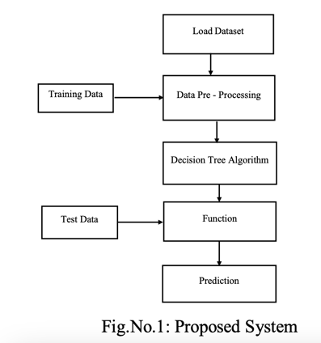

## Code submission (Github link)

https://github.com/9392473947/UpSkill-Campus

## Report submission (Github link) : first make placeholder, copy the link.

https://github.com/9392473947/UpSkill-Campus

# Proposed Design/ Model

In this project, the system makes use of the Machine Learning techniques to predict rate of crop yield. The programming language used is Python as it is widely accepted for new idea implementations in the field of Machine Learning. In this project, collected data set will be uploaded and prediction for crop yield will be generated by applying Machine Learning techniques like Random Forest Regressor and Decision Tree Regressor. The results depend on the information present in the collected data set. Accurate the information about the parameters in the collected datasets, better the results will be

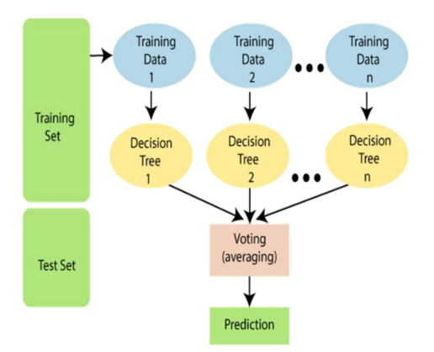

Flowchart of Crop Yield Prediction

## High Level Diagram (if applicable)

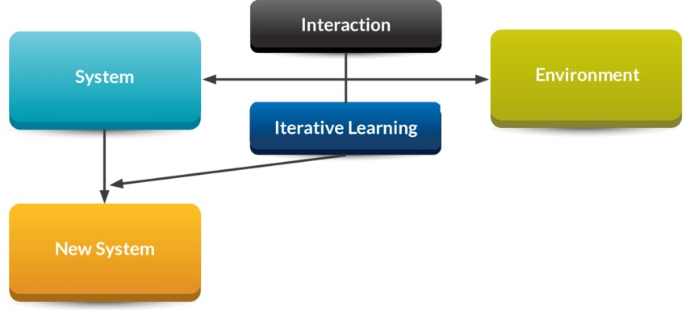

HIGH LEVEL DIAGRAM OF THE SYSTEM

## Low Level Diagram (if applicable)

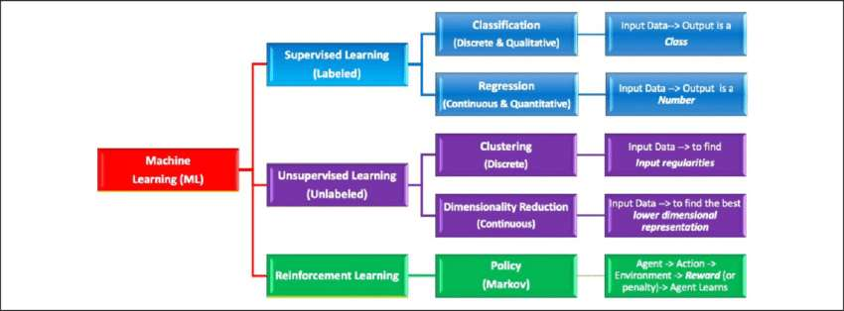

## Interfaces (if applicable)

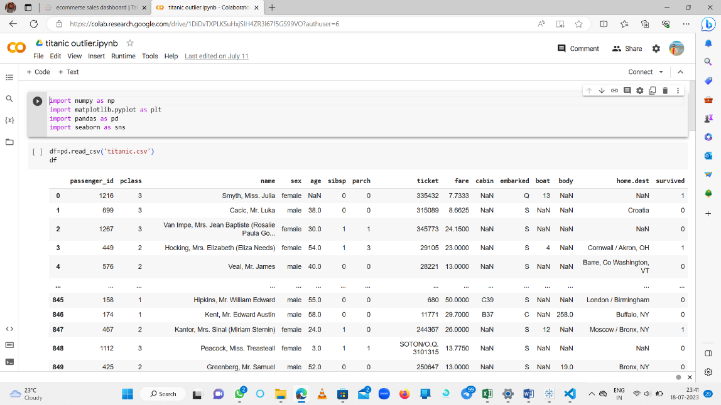

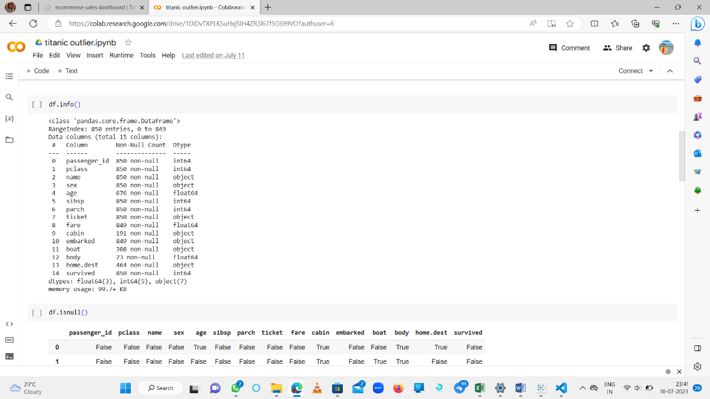

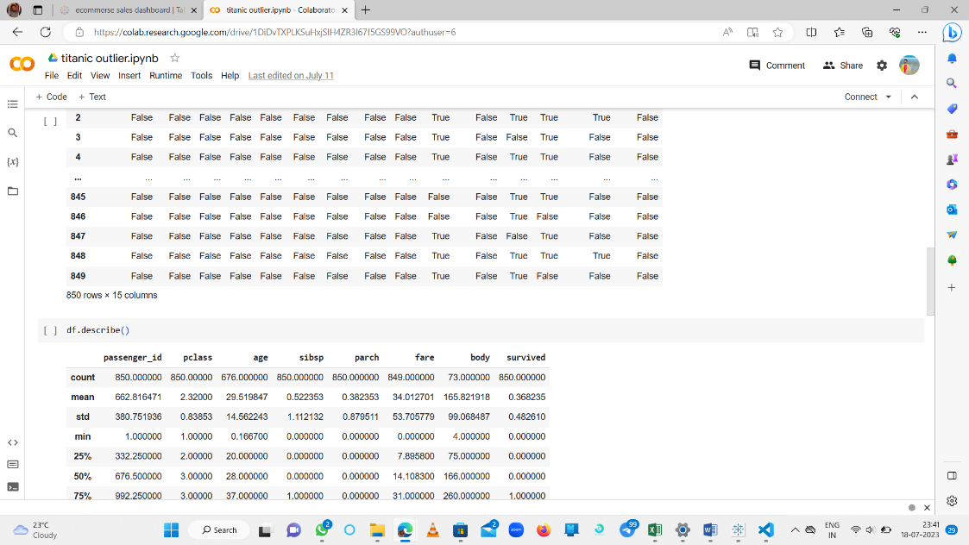

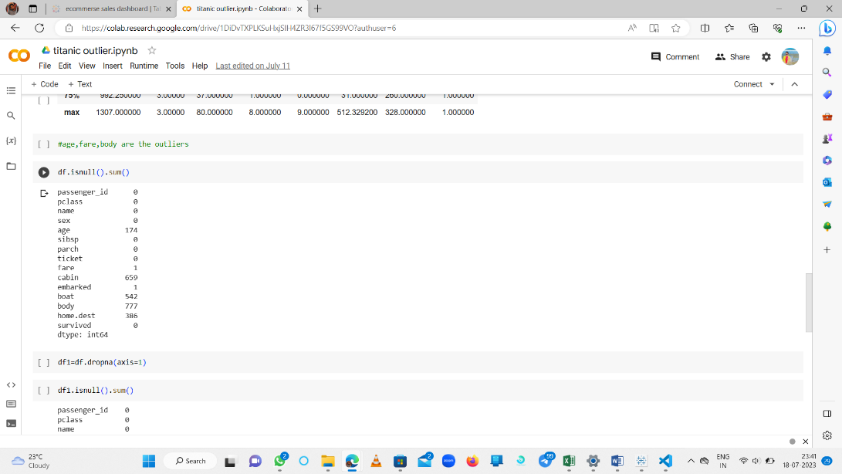

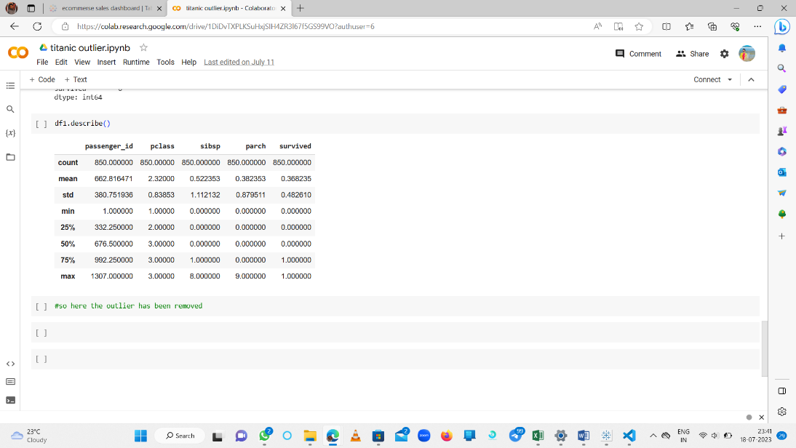

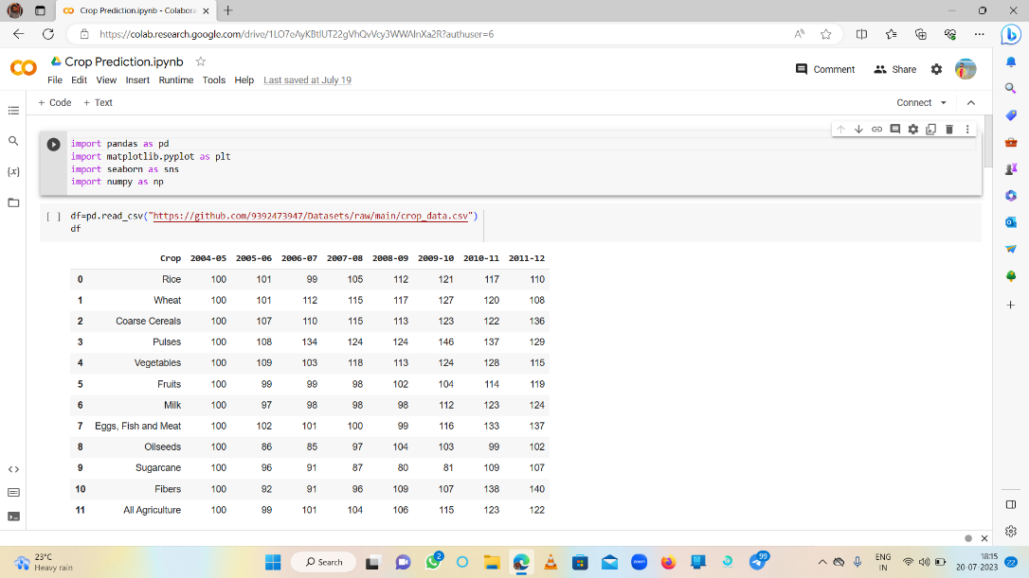

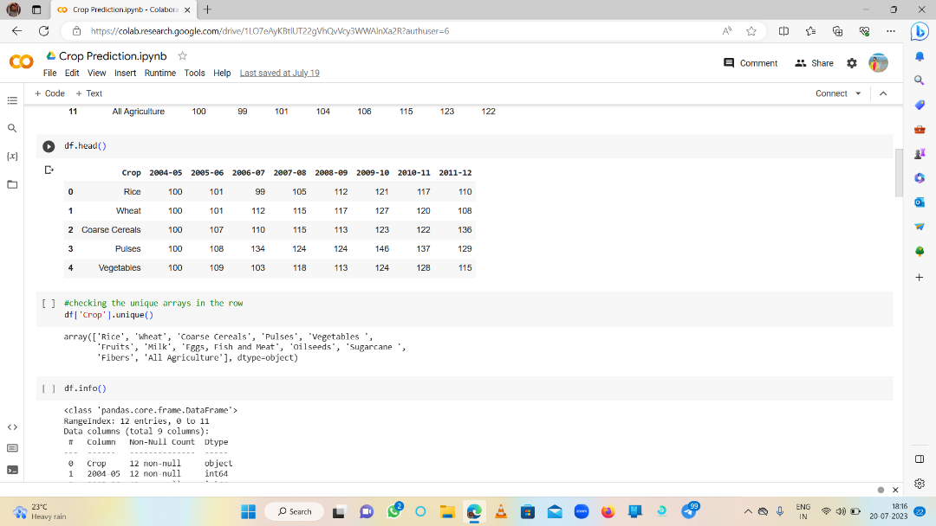

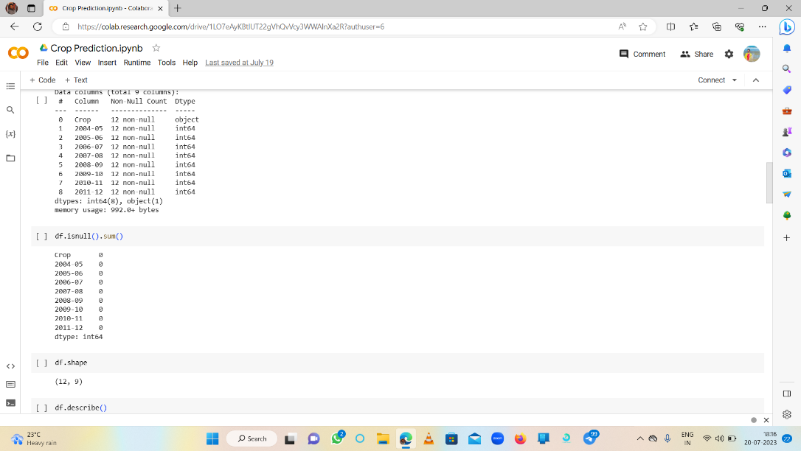

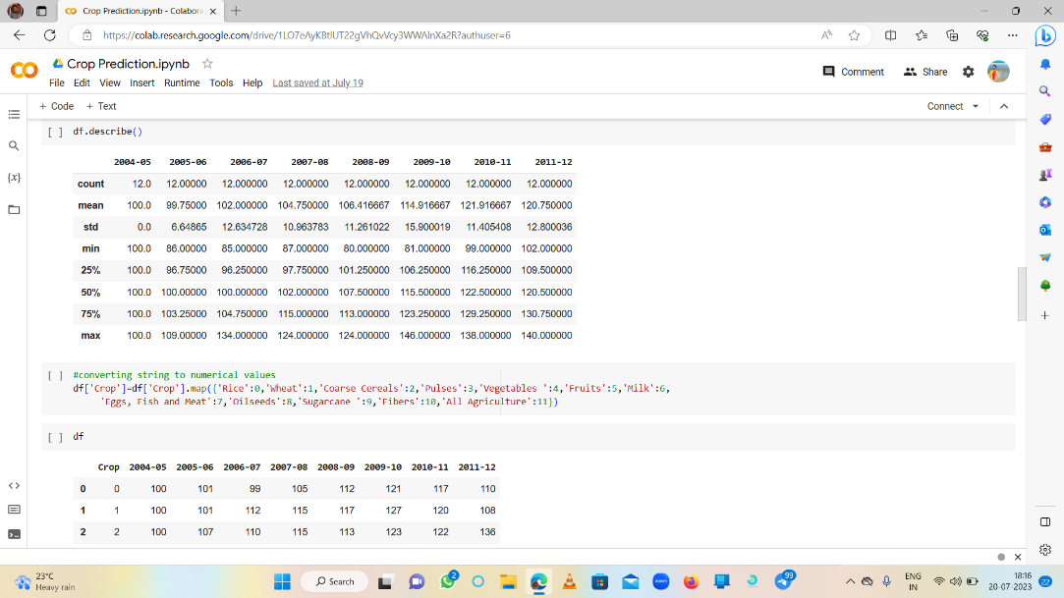

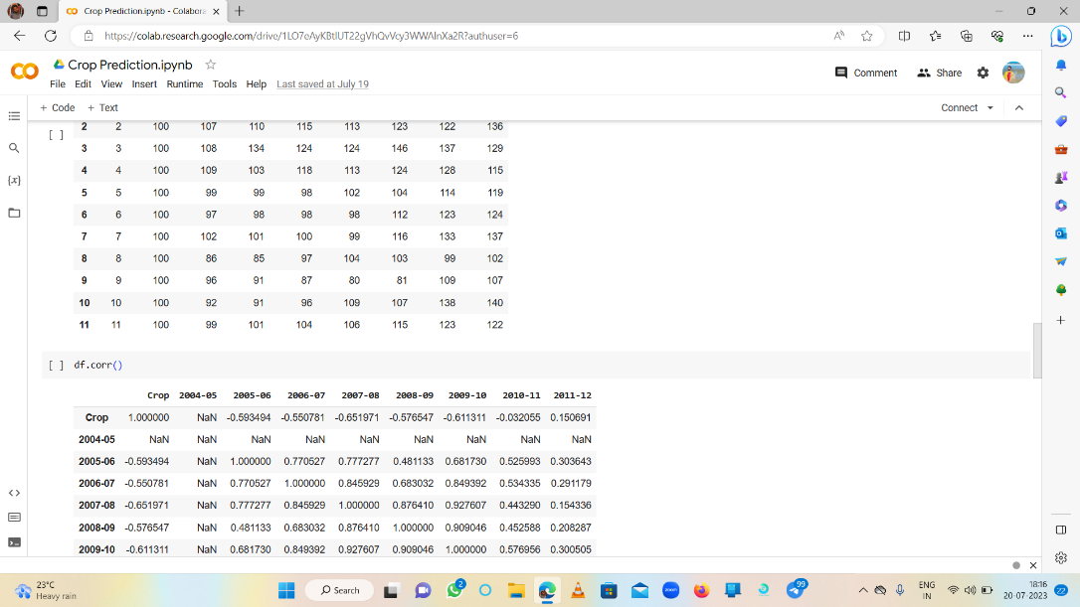

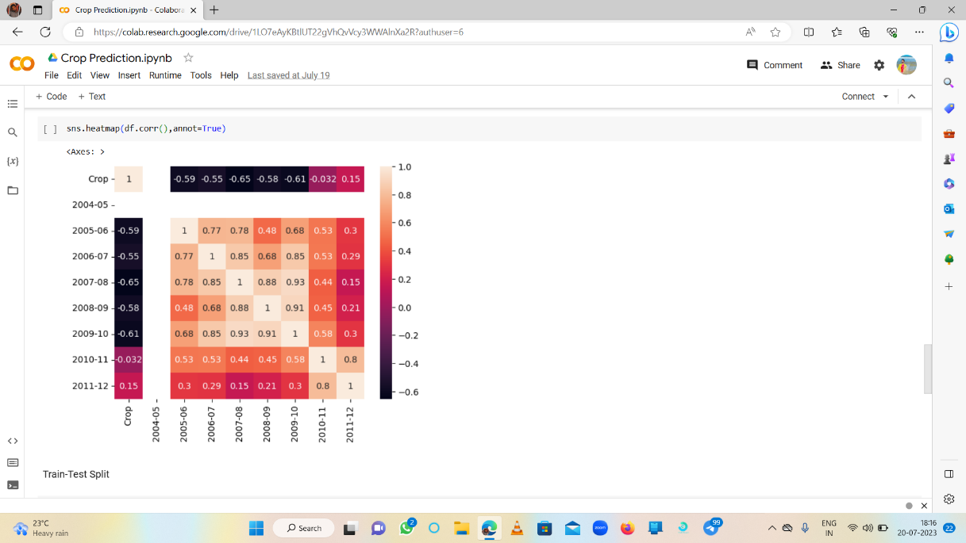**To find Correlation**

# Performance Test

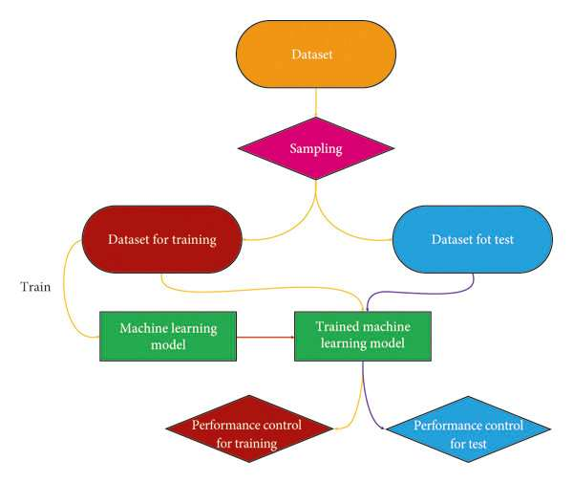

## Test Plan/ Test Cases

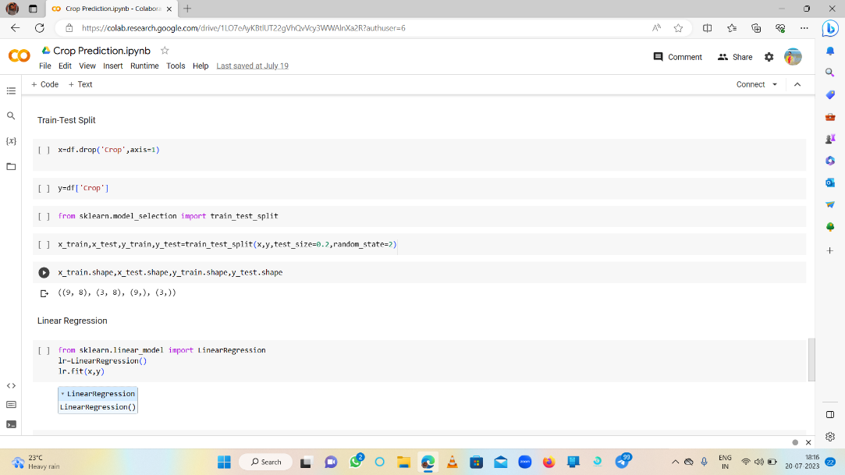

## Test Procedure

To perform a test procedure for predicting agricultural crop production in India using linear regression with the cost on the x-axis and the year on the y-axis, you can follow these steps:

1. Dataset Preparation:
   * Gather a dataset that includes historical data on agricultural crop production in India, along with corresponding cost and year values. Ensure the dataset is reliable and representative of different crops and regions.
   * Organize the dataset in a tabular format, with the cost values in one column (x-axis) and the corresponding year values in another column (y-axis).
2. Data Preprocessing:
   * Check for missing values in the dataset. If any are found, decide on an appropriate strategy for handling them, such as imputation or removal of incomplete records.
   * Normalize or standardize the cost and year values if needed to ensure they are on a similar scale. This step is crucial for linear regression models.
3. Splitting the Dataset:
   * Divide the dataset into two parts: a training set and a test set. The training set will be used to train the linear regression model, while the test set will be used to evaluate its performance.
   * The typical split is around 70-80% for training and 20-30% for testing, but you can adjust this based on the size and characteristics of your dataset.
4. Model Training:
   * Import a linear regression algorithm from a machine learning library such as scikit-learn in Python.
   * Fit the linear regression model using the training data, providing the cost as the independent variable (x) and the year as the dependent variable (y).
5. Model Evaluation:
   * Use the trained model to make predictions on the test dataset by providing the cost values.
   * Compare the predicted values with the actual year values from the test set.
   * Calculate evaluation metrics such as mean squared error (MSE) or R-squared to assess the model's performance. These metrics quantify the accuracy and goodness of fit.
6. Interpretation and Analysis:
   * Analyze the results to understand the relationship between the cost and year variables and their impact on agricultural crop production.
   * Interpret the coefficients of the linear regression model to determine the direction and strength of the relationship.
7. Refinement and Iteration:
   * If the model's performance is not satisfactory, you can experiment with different variations, such as including additional features or using more advanced regression techniques.
   * Repeat steps 4-6 with the refined model until you achieve the desired prediction accuracy.

Remember that linear regression assumes a linear relationship between the cost and year variables and crop production. If this assumption does not hold, you may need to explore other regression models or consider incorporating additional features into the analysis.

## Performance Outcome

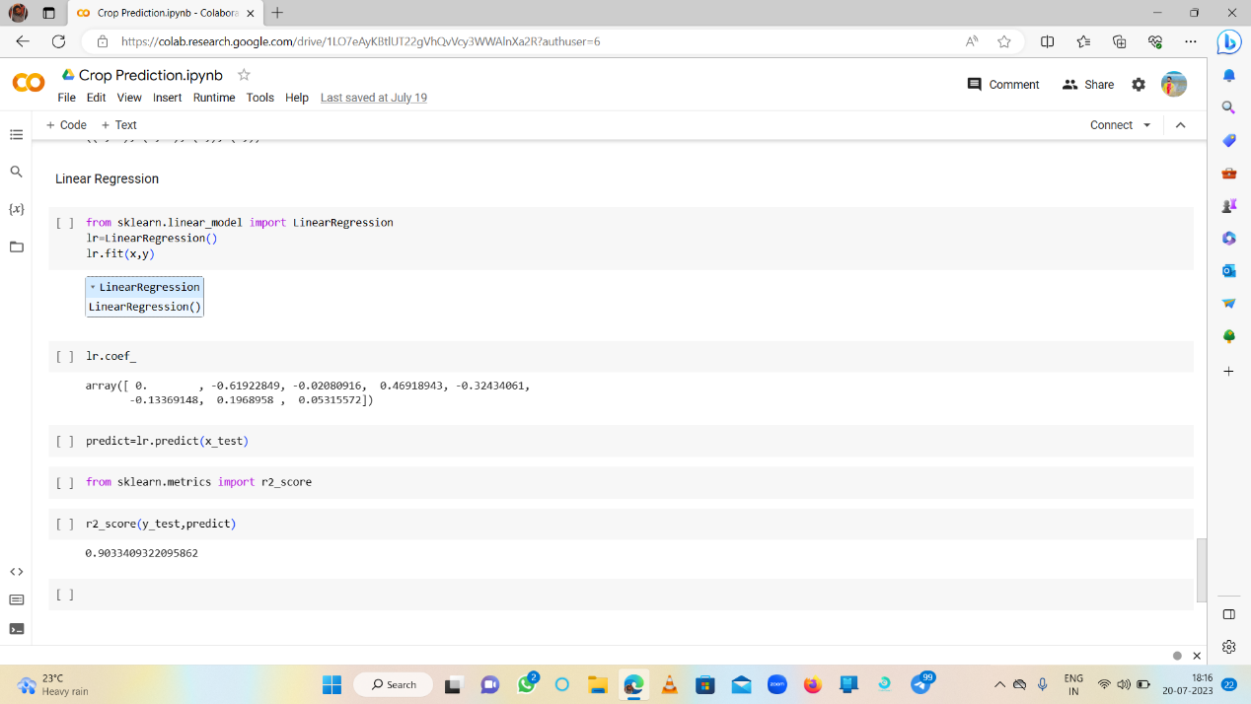

# My learnings

Studied the basics of data science and its applications. Studied about machine learning in depth. Glanced through the instructions of the internship program and understood the process. Went through the profile of UCT. Selected the project for the machine learning internship. Project Category: A. Agriculture, Project No. 4 Prediction of Agriculture Crop Production In India. Studied the various problems faced by farmers of India during Crop production. Went through the data of the crop production. Read and understood the basic concepts from the e-book Introducing-Data-Science-Machine-Learning. Glanced through the Impact-Of-Big-Data-On-Business and understood what is Big Data and its applications. Studied the difference between a Data scientist and the Data Analyst and how they contribute towards the project. Attempted the Quiz to test my intellectual capability. Gathered the information of Artificial Intelligence and Data Science and also understood the difference between the both. Learned how to map your career path with help of artificial intelligence and data science. Learnt about the skills which are required for artificial intelligence or data science or big data or machine learning engineer. Hence came to a conclusion that artificial intelligence and data science are inter-connected. So, specialization in either field requires a working knowledge of the other. To begin using ML-AI, studying data analysis is more necessary than understanding data science. Glanced through the introduction of Probability and statistics and revised the concepts of sample spaces, random variables, probability of an event, discrete c.r.v., probability distribution, other special distributions, large sample theory, parametric point estimation, etc. Learned what are the technical and non-technical skills required for a data scientist. The Top 5 Skills Crucial for Becoming A Data Scientist are Programming, Statistics and Mathematics, Machine Learning, Deep Learning and Big Data. Having a knowledge and expertise in these skills is essential for an ideal data scientist.

# Future work scope

In coming years, can try applying data independent system. That is whatever be the format our system should work with same accuracy. Integrating soil details to the system is an advantage, as for the selection of crops knowledge on soil is also a parameter. Proper irrigation is also a needed feature crop cultivation. In reference to rainfall can depict whether extra water availability is needed or not. This research work can be enhanced to higher level by availing it to whole India.